Geological Evidence Guide

Look for Evidence of Lava Flows
Lava flows leave behind many clues that help geologists understand how the lava flowed out of the volcano, as well as how quickly it cooled. Below are several clues left behind by the flow at the Columns of the Giants.
Columnar jointing happens when stagnant pools of lava cool slowly. As the lava cools and crystallizes into rock, the atoms in the lava become more organized and take up less space than when the lava was a hot liquid. As a result, the solidifying rock shrinks, causing cracks to form in the surface. The cracks radiate outward at 120-degree angles from one another, forming hexagonal shapes that lend the surface a honeycombed appearance. | 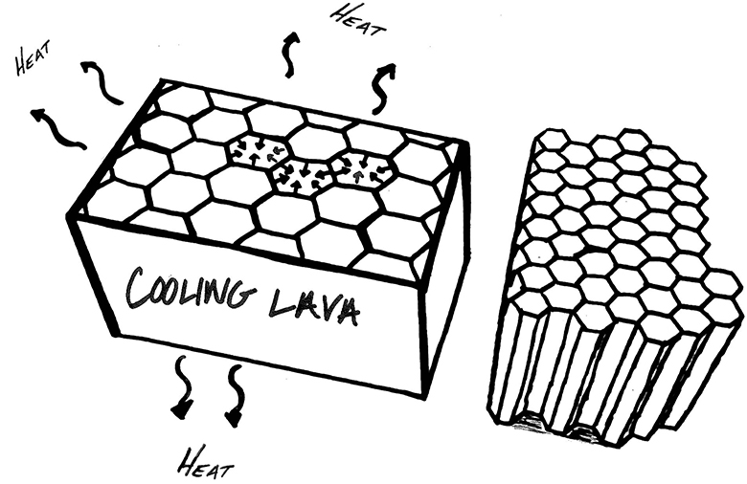
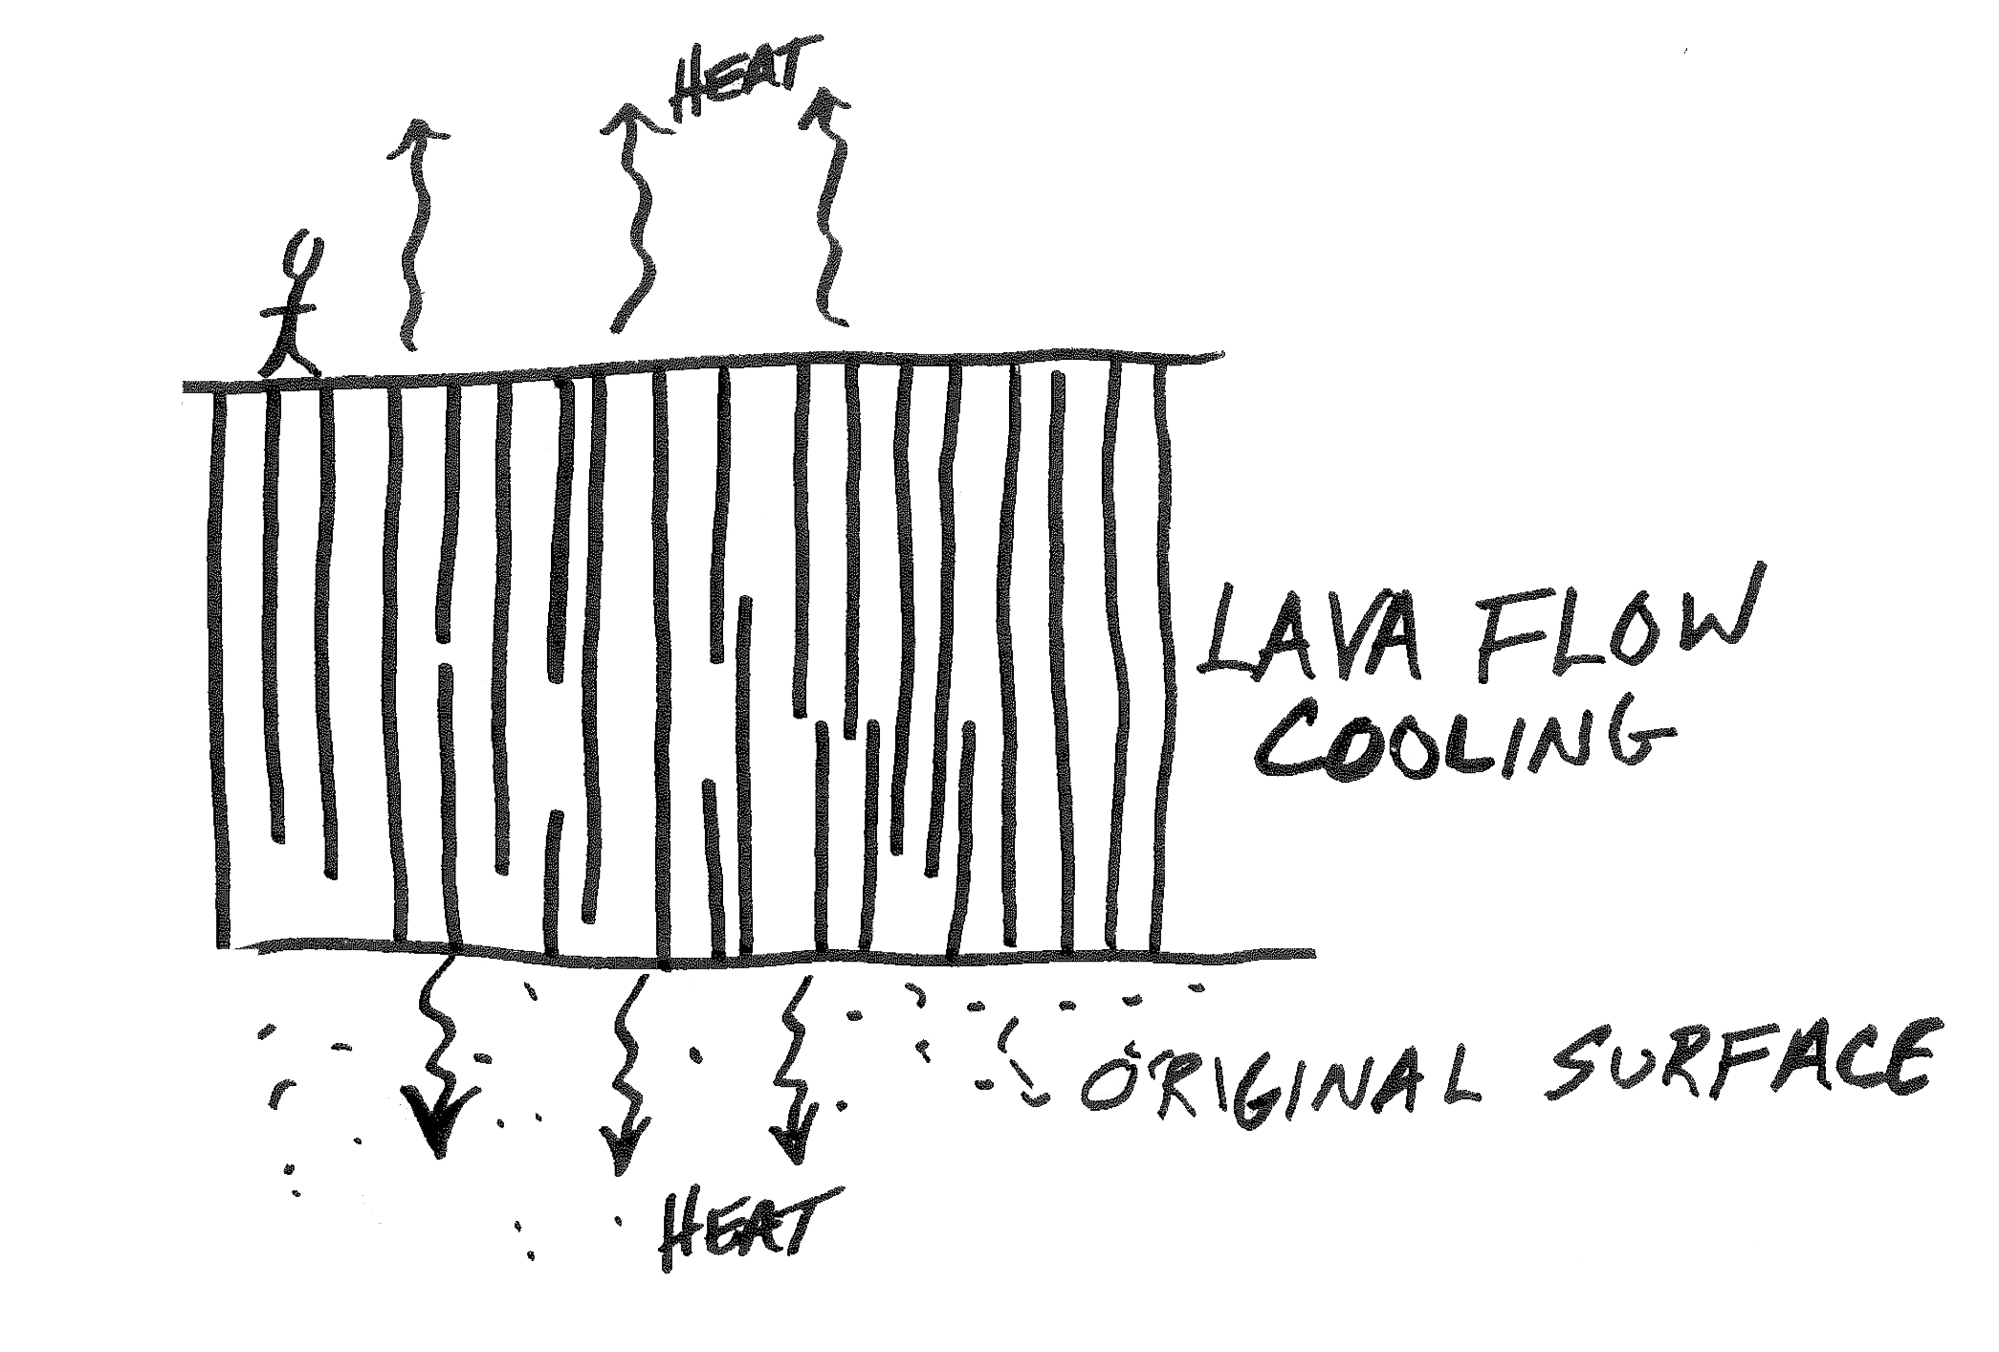  Over a cooling period of several decades, those cracks, called “joints,” also spread down through the solidifying rock, meeting other cracks spreading up from the bottom, and forming column-like shapes. | 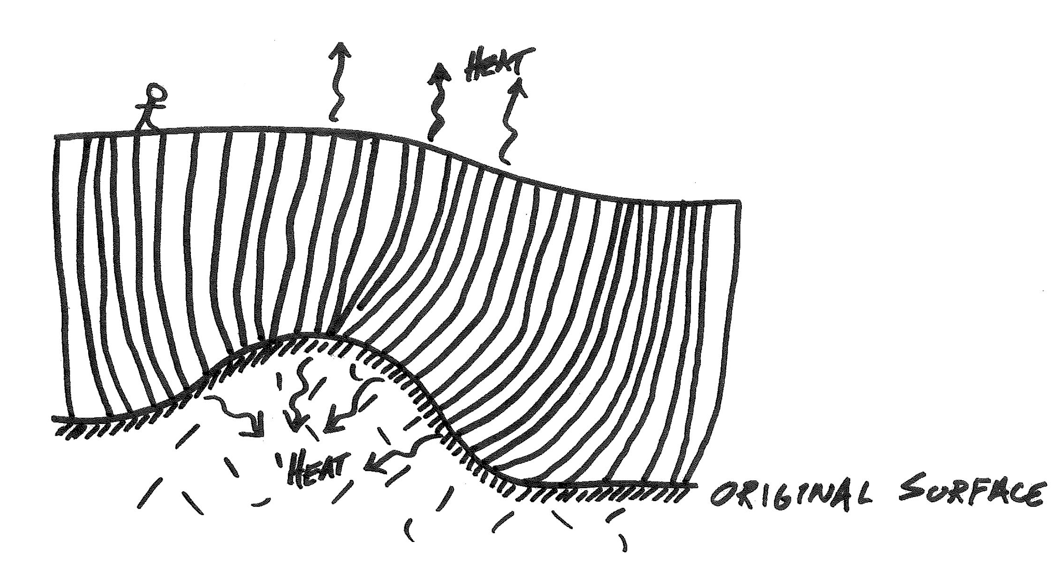  Columns form perpendicularly to the surface that the original pool of lava rested upon. These columns will lean or bend if the bottom of the lava pool lies on top of surfaces that are uneven, such as a hill or stream channel.
When lava cools particularly quickly, cracks form in a disorganized fashion, resulting in small columns that point in seemingly random directions. Disorganized jointing and columns are called entabulatures. | 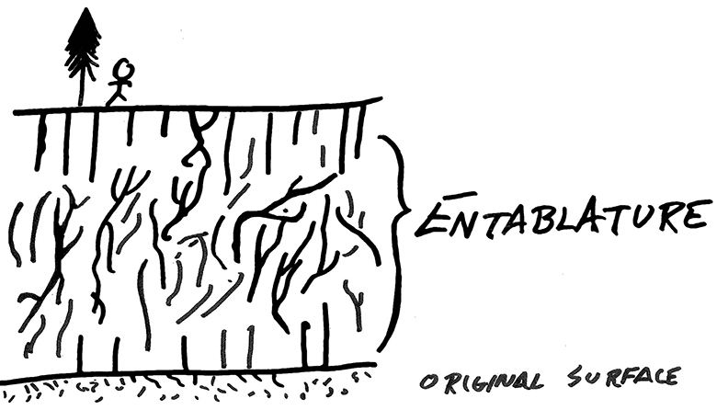
Examine and Identify Rocks
The Columns of the Giants, as well as the surrounding Sierra Nevada mountains, are part of a family of rocks called igneous rocks.
Igneous rocks form when magma (hot liquid rock) cools and solidifies, either underground or after erupting onto earth’s surface as lava. By examining the crystal size and composition of igneous rocks, you can infer their origins.

Igneous rocks that contain large interlocking mineral crystals (what geologists call a coarse-grained texture) formed from magma that slowly cooled and solidified miles beneath earth’s surface over a period of millions of years. | 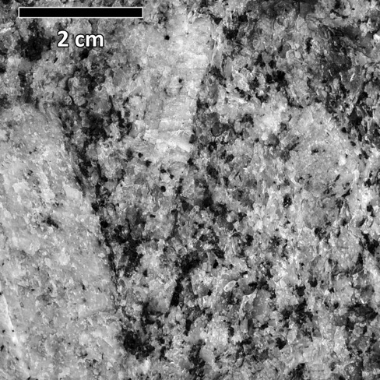
Fine-grained igneous rocks (as well as those with a glassy texture) likely formed in a volcanic eruption that occurred above ground and cooled very quickly in a matter of hours, days, months, or years. | 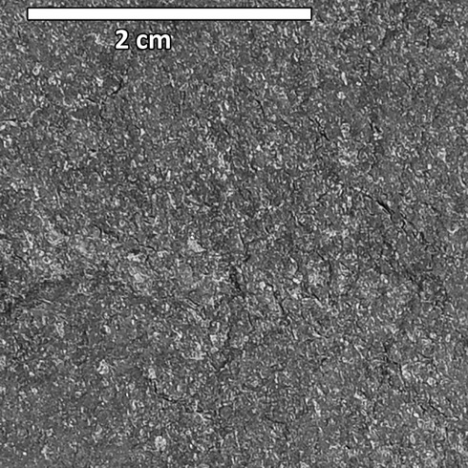

Look for Evidence of Glaciers
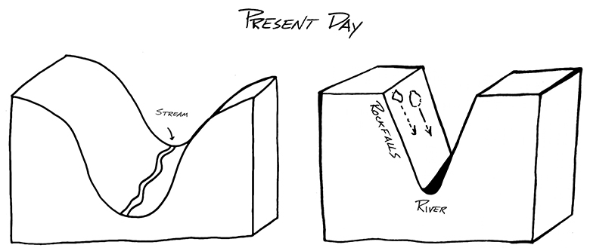
Scientists can gather evidence of glaciers that have retreated by studying freshly exposed rock.

Valleys carved by a river appear V-shaped (see the image to the right). Glaciers flowing down V-shaped river valleys will pluck and grind rocks, widening the valley into a U shape.,

U-shaped valley (left) and V-shaped valley (right).)
Glacial Striations  When a glacier with rocks and dirt stuck in its base grates the ground over which it flows, it creates parallel scrape marks on rocks.  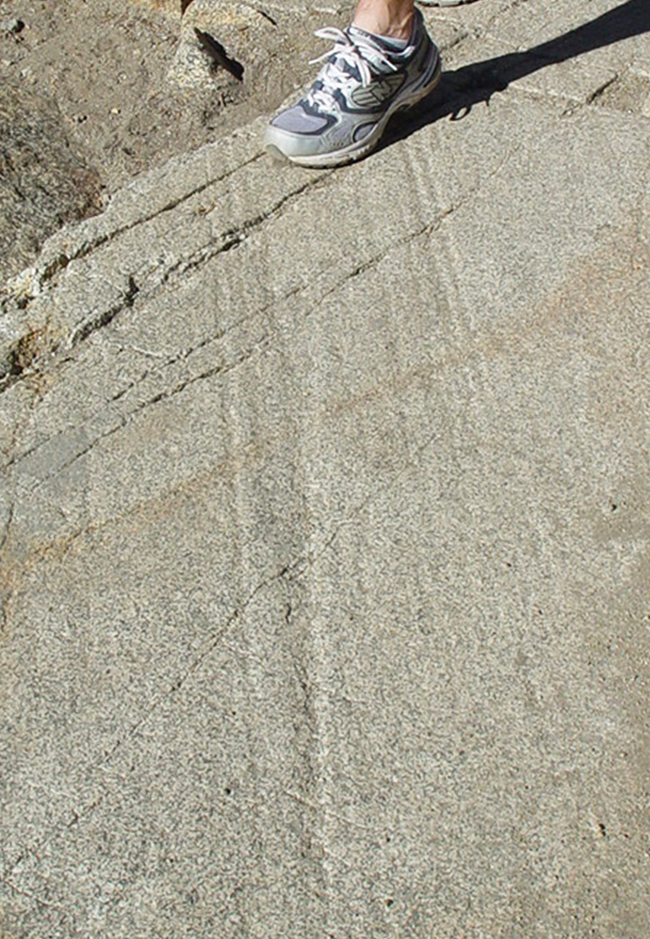 | Glacial Erratics  These are rocks that were trapped inside and transported by a glacier. When glaciers melt, they leave the rocks behind, typically on ground composed of a different type of rock.  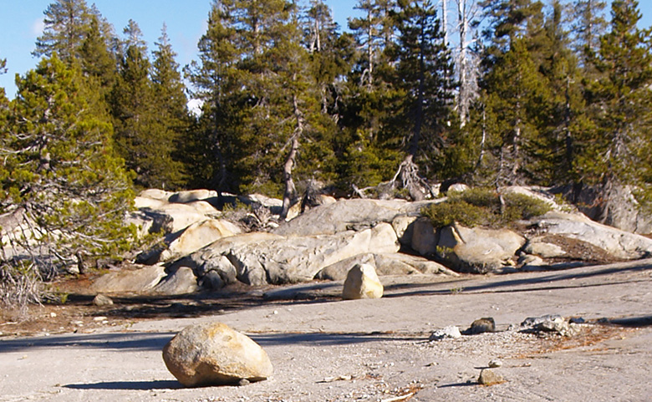
Absence of soil
As glaciers scour an area, they strip the surface of all soil.
