Data and Observation Sheet

Directly after adding your first layer, answer the questions below.

What do the water and sediment look like?

Why do you think you need to wait at least a day to add the next layer of sediment to your core?

CORE SECTION (Use the letter from your Scaled Sediment Layer Sheet): ____
Layer | Height of Sediment Layer (cm) | Total Sediment Height (cm) | Observations of Sediment Layer  (What color are the sediments? What do they consist of? What size are the particles? Too small to see, or can you see individual pieces?)
Layer 1
Layer 2
Layer 3
Layer 4
Layer 5

Combine data from the four simulated core sections.
Insert data from “Height of Sediment Layer (cm)” columns for each section.
 | Section A | Section B | Section C | Section D
Layer 1
Layer 2
Layer 3
Layer 4
Layer 5

Arrange your simulated core sections from oldest to youngest.
Using the data for all four core sections and the graph of sediment thickness below, try to arrange your four models in order, from oldest layer to youngest layer.
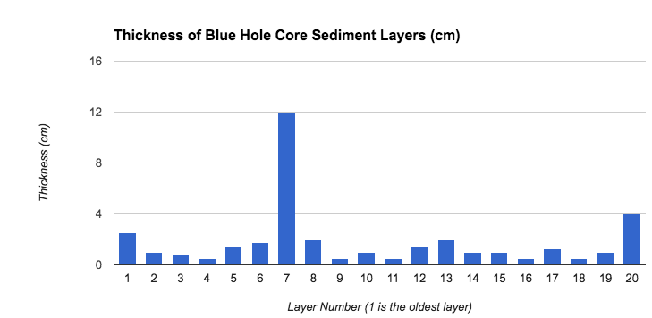
 | CORE SECTIONS
OLDEST |  |  |  |  | YOUNGEST

