Essential question: Do Finger Wrinkles Improve Grip?

Students investigate the unique, intriguing question: Do fingers wrinkles help you grip wet objects? Using observations they make of their own finger wrinkling structure, students hypothesize some potential functions of finger wrinkles. Students are then introduced to a relatively new hypothesis through video: that finger wrinkles from soaking your hand improve our finger’s gripping function when wet. Students conduct a (literally) hands-on experiment to test whether or not finger wrinkles improve grip on wet objects. Students will collect and interpret quantitative data, using this data to argue whether or not the hypothesis is supported.

Target Ages: Grades 6-8
Content Areas: Biology, Engineering and Design
Topic tags: Structure and Function, Physiology, Adaptation, Neurology, nervous system, modeling, inquiry, experimental design, data analysis and presentation
Time required: 60 minutes

Focus Skills: Observation and inference, measurement and counting, science process skills.
Supported modalities: Visual, auditory and tactile modalities are supported
Assessment: Students use their data or simulated data to argue whether or not the function of finger wrinkles is to improve the grip of wet objects.
Accessibility: This activity will work best with students who are able to see and feel finger or foot wrinkling. At least one member in each group needs to be able to pick up wet objects. A student who can keep time is also a necessity for this project.

Standards:
Framework for  K-12 Science Education | Disciplinary Core Ideas addressed:  LS1.A: Structure and Function  Multicellular organisms have a hierarchical structural organization, in which any one system is made up of numerous parts and is itself a component of the next level.  Crosscutting concepts: Structure and Function  Complex and microscopic structures and systems can be visualized, modeled, and used to describe how their function depends on the relationships among its parts, therefore complex natural structures/systems can be analyzed to determine how they function. (MS-LS1-2)  Science and Engineering Practices: Conduct an investigation to produce data to serve as the basis for evidence that meet the goals of an investigation
NGSS:  MS-LS1-3 | Use argument supported by evidence for how the body is a system of interacting subsystems composed of groups of cells. [Clarification Statement: Emphasis is on the conceptual understanding that cells form tissues and tissues form organs specialized for particular body functions. Examples could include the interaction of subsystems within a system and the normal functioning of those systems.] [Assessment Boundary: Assessment does not include the mechanism of one body system independent of others. Assessment is limited to the circulatory, excretory, digestive, respiratory, muscular, and nervous systems.]
CCSS.ELA-Literacy.WHST | CCSS.ELA-Literacy.WHST.6-8.1b Support claim(s) with logical reasoning and relevant, accurate data and evidence that demonstrate an understanding of the topic or text, using credible sources.

Objectives: Students Will Be Able To
- Use experimental evidence to evaluate whether finger wrinkles improves finger gripping function when wet.
Materials:
- Projector or interactive whiteboard and computer with sound
- Internet access or “Getting a Grip on Finger Wrinkles” video pre-downloaded onto computer
For each group of students:
- Smooth plastic ruler with a hole at one end (without raised lines or numbers)
- Large paperclip, straightened out
- Large water bottle with screw cap, with a looped lid for paperclip attachment
- Notebook or student data sheet
- Bowl of water for soaking fingers

Activities and Sequence:
- Entrance: Ask a student volunteer in each lab group (or just a couple distributed throughout the room), to hold their non-dominant hand in a small dish of water (small food storage cups or observation dishes work well for this). The goal is to make sure that every student in the class will be able to see and sketch finger-wrinkling patterns later in the lesson.
- Video: Does finger wrinkling improve wet grip function? (Video 3min 25s)
Show students the finger wrinkling video. If you would like to obscure the results of their experiment until after your students replicate their experiment, stop the video at 2m 40s. Ask students the following questions:
- What other natural structures share the same structural pattern that finger wrinkling does?
- What human-designed structures share the same structural pattern of finger wrinkles?
- What was this group of scientist’s hypothesis for the structure of finger wrinkles? What do they think that these structures are used for?

- Experiment:
Are wrinkled fingers better at gripping wet objects than non-wrinkled fingers? (40 minutes)
Provide students with the experimental protocol and orient them to a supply station. Before releasing students to retrieve items, review appropriate use of materials. This activity may result in splashed water, so make sure that electrical outlets and important documents are cleared from the work area and that students are advised of the potential slipping hazard.
- Assessment: Do finger wrinkles improve the ability to grip wet objects?
Students answer this question, justifying their responses with the data collected in the experiment. In their presentation of the results, students should address the following questions:
- What was the question being asked in this study?
- How was grip measured? If grip is good, what results would you expect? If grip was bad, how would your results be different?
- What was your hypothesis about the relationship between the presence of finger wrinkles and the ability to grip? What was that hypothesis based on?
- Summarize the results of your lab group: overall were your lab mates better at gripping with non-wrinkly or wrinkly fingers? How can you tell? What calculations did you have to perform?
- Does this data support or reject your hypothesis?
- What could have caused some error in your experiment? How could the experimental setup be improved? Are there other ways that you could test the same hypothesis?

Anchoring Media:
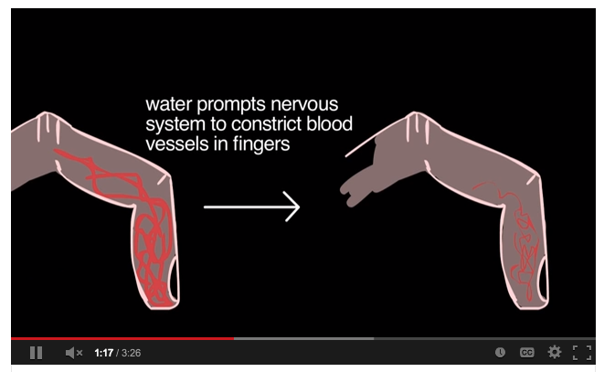

Video: Getting a Grip on Finger Wrinkles (3m 25s )
http://www.sciencefriday.com/video/01/11/2013/getting-a-grip-on-finger-wrinkles.html

Why do your fingers get pruney after a swim? Only a handful of researchers, including Einar Wilder-Smith, Mark Changizi, and Tom Smulders, have looked into the phenomenon. Publishing in Biology Letters, Smulders lends a hand to the hypothesis, set forth by Changizi and colleagues, that finger wrinkles improve our grip of wet objects.

Supporting Media
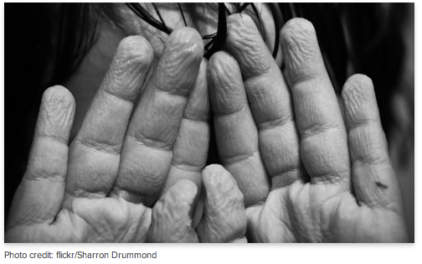

Audio: Getting a Handle on Why Fingers Wrinkle (8m 59s)
http://www.sciencefriday.com/segment/01/11/2013/getting-a-handle-on-why-fingers-wrinkle.html

Why do your fingers get pruney after a long water bath? Only a handful of researchers (ever) have looked into the finger-wrinkling experience. Reporting in the journal Biology Letters, researchers make the case for finger wrinkles as treads -- wet wrinkled fingers seem to grip better than wet smooth ones.

http://rsbl.royalsocietypublishing.org/content/9/2/20120999/suppl/DC2 : Watch a (rather lengthy) video of the experimental procedure testing the improved handling ability of people with wrinkled fingers

Original Articles
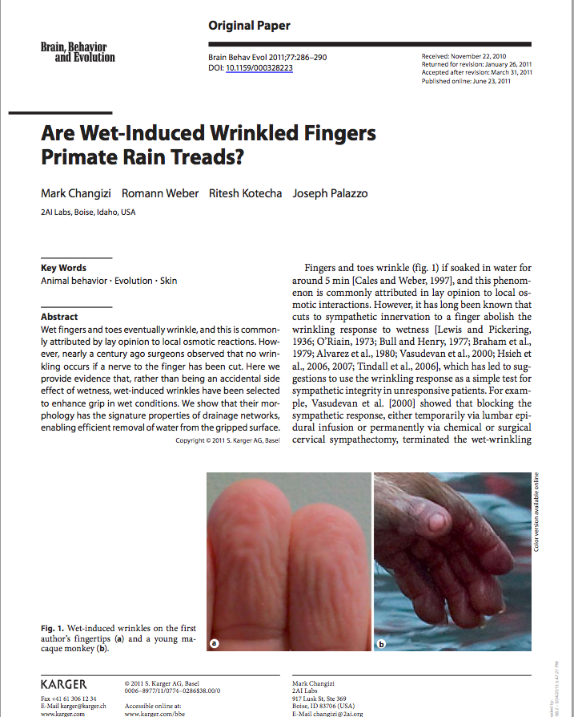 | 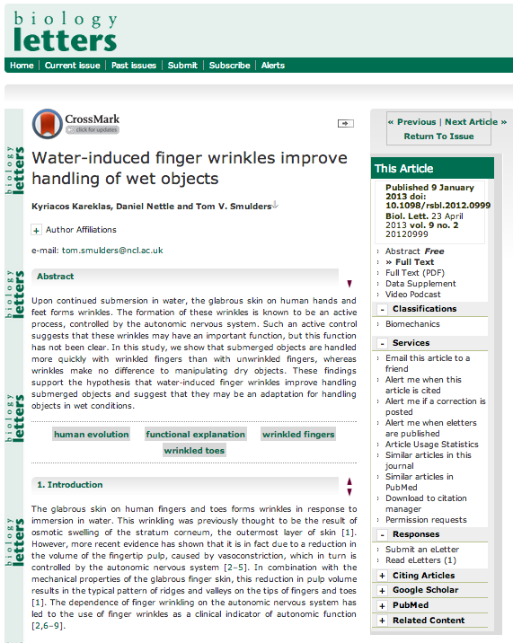
Changizi, M., Weber, R., Kotecha, R., & Palazzo, J. (2011). Are wet-induced wrinkled fingers primate rain treads?. Brain, Behavior and Evolution, 77(4), 286-290.  (http://www.karger.com/Article/Pdf/328223 ) | Kareklas, K., Nettle, D., & Smulders, T. V. (2013). Water-induced finger wrinkles improve handling of wet objects. Biology letters, 9(2).  http://rsbl.royalsocietypublishing.org/content/9/2/20120999.full

