Columns of the Giants Guided Questions

Stop 1

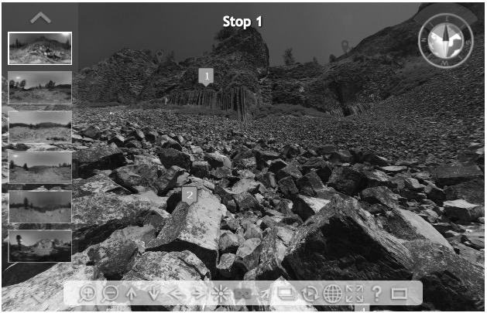
- This is the namesake area for the Columns of the Giants. The entire hill in this scene is made of the same rock type.
  - Why do you think this area was named Columns of the Giants?
  - What clues in the rocks suggest how the rocks and this hill were formed?
  - There are two distinct rock “layers” here. Why? Refer to the section in your Geologic Evidence Guide that discusses columns and entablatures.

- "Talus" is the word geologists use to describe broken rocks that have fallen from a higher elevation.
  - Do you notice any interesting shape patterns in the individual pieces of talus?
  - Where do you think this talus came from? What evidence supports your idea?

- This is a fairly freshly broken rock surface, which makes it easy to identify the rock type.
  - Is the rock dark in color or light in color? (Consult the Rock Identification Chart.)
  - Do you notice any large, visible crystals? Zoom in to the rock to get a better view.
  - Based on your observations, what type of rock do you think this is?

- The yellow-green, dark black, dark brown, and rusty-colored spots on top of the rocks are lichens. Lichens, which consist of algae and fungi living symbiotically, generally grow about 2–5mm per year. The rocks in this talus pile are about 50cm in diameter.
  - Would freshly fallen talus have lichen on it?
  - Can you think of a way to use this lichen to help you figure out how many years it has been since the rocks fell?

- Make several observations about where the trees and plants are growing in this scene.
  - Why are the trees and plants growing where they are? Why are there areas with no trees or plants growing?

- To help you get a feeling for how big things in this scene are, this column is about 70cm tall and sits at the end of the Columns of the Giants Interpretive Trail.

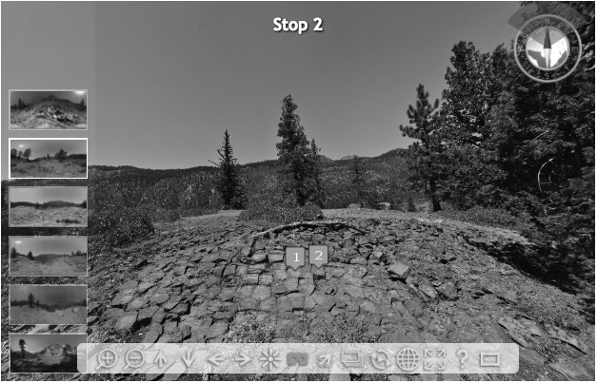
Stop 2

- You are now standing on top of the Columns of the Giants, directly above Stop 1. First, compare this location with the rest of the scene. The size of this rock is about 25cm across.
  - What is different about the rocks in this spot versus those just a few feet away, to the south and west (behind you)?
  - The rocks here have cracks (joints) that make a pattern. Focus on the shapes they make.
    - How many sides does each rock have?
    - Using your Geological Evidence Guide, how do rocks with this kind of jointing pattern form?

- Notice the flat, smooth surface of this area.
  - If you zoom in to this area, you should see parallel sets of grooves that run east to west on the flat surfaces.
    - What do you think could have made such grooves?
  - In some places the oxidized (“rusty”) flat areas of this rock surface are chipped, exposing fresh surfaces of the rock and making it easier to identify. Based on the dark color of the freshly exposed surface and the lack of large crystals, what kind of rock do you think this is? Use your Rock Identification Chart to help you.
  - Is this rock generally similar or different to those observed at Stop 1? How?

- Use the apple for scale. About how big do you think this rock is? Note: Author practices Leave No Trace and did not leave the apple behind.

- The rocks at Tag 4 and Tag 5 are interesting. Take a good look at their shape and color. Compare them to the majority of the rocks lying around the area.
  - What is similar or different about these rocks?
  - Stop #4 and Stop #5 will provide more examples of these rocks to help guide your inquiry.

- Here is more of the same rock type you observed at stop #4. What is similar or different about these rocks compared to nearby rocks?

- The black chunks in this area appear to be the charcoal remnants of a possible lightning-sparked log that smoldered. There is no evidence of a human-influenced disturbance in this particular area.

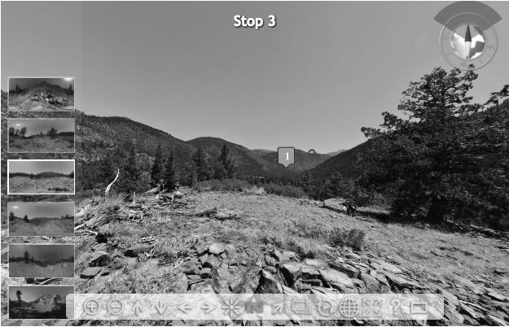

Stop 3

- The view looking east, up canyon, is the main purpose of this stop. The canyon is about one mile wide at the base.
  - Does this canyon resemble a U-shape or V-shape?
  - What does the shape of the canyon tell you about its formation?

- What is the general rock type in this area? It should become easier to identify this rock, because you see it at nearly every site. Why do you think all of these rocks are the same type?

- Zoom in to this pile of rocks. Do you notice any similarities to those seen at the previous stop (Stop #2)?
  - What might be responsible for the flat and smooth surfaces seen at the top of this pile?

- A lack of soil generally means the surface is geologically young (less than several hundred thousand years).
  - Based on the soil and plant life, do you think this is a geologically young or geologically old area?

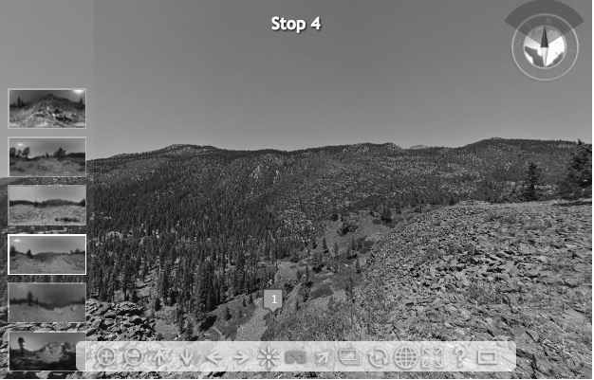

Stop 4
- Look down on the columns and talus piles in Tag 1 (these also appeared at Stop #1).
  - What does the orientation of the columns suggest about how the lava that formed these rocks cooled? (Consult your Geological Evidence Guide.) Did the cooling occur slowly and uniformly from the bottom and top, or was the cooling relatively quick? What evidence supports your idea?

- Take a closer look at this rock, ignoring the black lichen spots. This rock is different from the rocks underneath it.
  - Based on the rock’s color and crystal structure, what kind of rock is this?
  - How did this rock likely form? Use your Rock Identification Guide to help you.
  - How could such a large rock (1.5m x 0.70m x 0.65m) end up on top of this cliff?
  - Take a close look at the tree root under the rock. Which came first, the rock or the root? What evidence supports your conclusion?

- Highway 108

- The rock here is granite. It has been rounded and smoothed by a natural process.

- This is the western extent of the rocks that make the Columns of the Giants.

- Here’s a backpack for scale. It’s about 80cm tall.
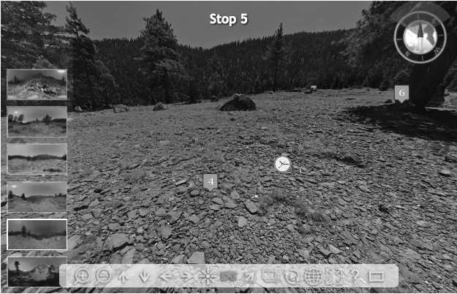
Stop 5

- This is the best view west (downstream) of the canyon in which the Columns of the Giants formation resides. Does the valley generally make a V shape or a U shape? What does the shape of the valley tell you about the geologic history of the area?

- How did a rock this large (2m x 1m x 1m) come to rest atop a steep cliff?
  - What kind of rock is this? Use its color and crystal shapes to help you determine the rock name. (Ignore the black lichen spots.)
  - Is this big boulder the same type of rock as those on which it sits? How do you know?
  - Does the rock appear to be sunken into the rocks beneath, or is it perched atop them?
  - What other field trip stops display a similar type of rock to the boulder? (Look at all of the stops!)
  - What could have easily moved a boulder of this size?
  - Click on the 3D model icons located on the nearby granite boulder to see it in 3D.

- How did a rock this large (.6m x .5m x .4m) get perched atop a steep cliff?
  - Use the same observations that you used in Tag #2 to explore this rock. How did this rock get here, and where did it come from?

- What type of rock makes up the majority of this flat area?

- Zoom in to this area, or consult the nearby 3D model. There is a small exposed section of very flat, smooth, dark-colored rock. It has parallel scratch marks running across the face of the rock that point directly towards the west (down canyon).
  - What could have produced these marks, as well as left behind huge boulders?

- Backpack for scale (about 80cm).
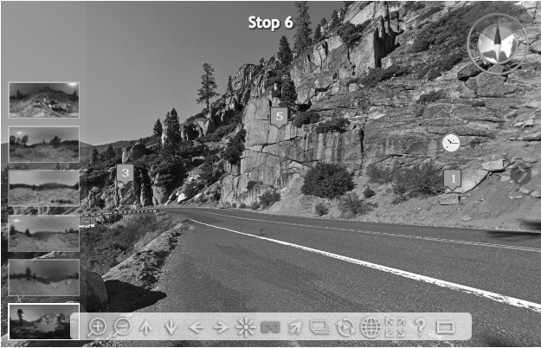

Stop 6
- The mineral crystals that make up rocks can tell amazing stories.
  - What do you notice about the color of these rocks?
  - Do you notice anything about the crystals in these rocks that might help a geologist learn about their story? Are the crystals large or small? Are they all the same size?
  - What type of rock might this be, based on the color and crystal size?
  - Do these rocks have any similarities with those seen at other stops?

- Use the local topography to make a hypothesis about how glaciers moved across the landscape.
  - What do you notice about the steepness of the highway at this spot?
  - What would happen if you spilled a bottle of water on the road? Which direction would it flow?
  - What would happen if you put a large, heavy block of ice on the road? Would it stay put? Would an even larger block of ice stay put, or would it flow down the road as well?
  - What useful elevation clues do this spot provide about how glaciers may have moved across this landscape?

- Freshly Broken Surface
This part of the rock was recently broken (probably during highway maintenance). Freshly broken surfaces haven't had time to oxidize, so they show the "true" colors of the rock, not the oxidized orange.

- The Columns of the Giants formation is located just behind this mountain where the valley curves to the left. If you had X-ray vision, you'd see it. Based on your view here, would the Columns of the Giants appear to be below or above this location?

- The cracks in this rock are called joints. How do the patterns of cracks in these rocks compare to those seen at the Columns of the Giants? What is similar? What is different?

